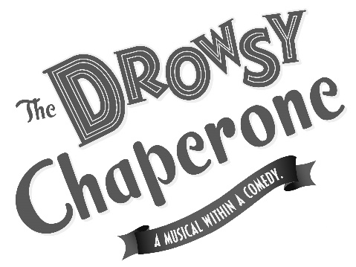

Book by

Bob Martin & Don McKellar

Music and Lyrics by

Lisa Lambert & Greg Morrison

**April 12, 13 & 14,2018 at 8 PM**

**April 14 & 15, 2018 at 2 PM**

Music Director **∙** **Justin Adams**

Stage Director **∙** **Larry Jansen**

This contemporary Broadway hit is a snarky peek at the Jazz Age musical and all of its hilarious tropes. While reminiscing on the golden age of American musical theater, a Man in a Chair plays his favorite cast recording, which comes to life in full-fledged musical buffoonery! Impending nuptials gather a cache of cliché characters from a bygone era: a drunken diva, a Latin lothario, an airy blonde, a clumsy groom, and gangsters looking to pounce at every turn. Several cases of mistaken identity threaten to spoil the affair, but the daffy dowager hostess is determined to see it through even if it means turning to the unorthodox.

Winner of 5 Tony Awards and 7 Drama Desk Awards, this preeminent team has crafted a gem of a hit that will hilariously transport any avid theater-goer through the lost annals of a forgotten era and back again!

Original Broadway production of The Drowsy Chaperone produced by Kevin McCollum, Roy Miller, Bob Boyett, Stephanie McClelland, Barbara Freitag and Jill Furman.

Rose Valley Chorus and Orchestra

**Non-Profit Org.**

U.S. Postage

PAID

Permit No. 271

Media, PA 19063

P.O. Box 414

Media, PA 19063

Return Service Requested

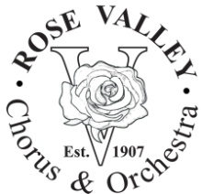

**ORDER FORM –** Tickets are valid for any performance of the show. **For the Thursday, April 12th performance only: Admit 2 per ticket purchased** (does not include complimentary tickets).All seating is General Admission.

**TICKETS** Advanced (Door Price)

____ Adults @ $17 = $________ ($20)  
____ Seniors 60+ @ $14 = $________ ($17)  
____ Students @ $14 = $________ ($17)  
____ Children 12&under @ $7 = $________ ($7)  
____ Group Rate @ $12 = $________ ($12)

Group rate is for 10 or more adults attending the same performance.   
For Group, indicate date/time:

**SPONSORSHIP** - Please consider a tax-deductible contribution for which you will receive complimentary tickets and your name listed in the playbill. All submissions must be received no later than April 1, 2018.

Level: Contribution: Tickets:

Angel $500 10  
Benefactor $250 6  
Patron $100 4  
Friend $50 2

Name in Playbill:

(Please print this information)

TOTAL ENCLOSED FOR THIS ORDER: $

Name

Address

Phone

Email

Send your check, this form, and a stamped, self-addressed envelope to:  
**ROSE VALLEY CHORUS & ORCHESTRA ● P.O. BOX 414 ● MEDIA, PA 19063**

**PERFORMANCE SITE**

**Strath Haven Middle School**

**200 South Providence Road (PA-Route 252)  
Wallingford, PA 19086**

Directions available ONLINE, (Bing, Google, etc.), or on our website:  
**www.rvco.org**

or CALL **610-565-5010** for recorded directions.  
Detailed directions will be sent with all mail order tickets.

**Order tickets ONLINE with the PayPal shopping cart feature on our website. Print your receipt and present it to the box office when you pick up your tickets at show time!**

“The Drowsy Chaperone” is presented through special arrangement with Music Theatre International (MTI). All authorized performance materials are also supplied by

MTI, 421 West 54th Street, New York, NY 10019

Tel.: (212) 541-4684 Fax: (212) 397-4684 www.MTIShows.com

